TOPIC 5 : GREEDY ALGORITHMS

EXP 1: Maximum Coins You Can Have

Aim: To find the maximum number of coins you can collect using a greedy strategy.
CODE
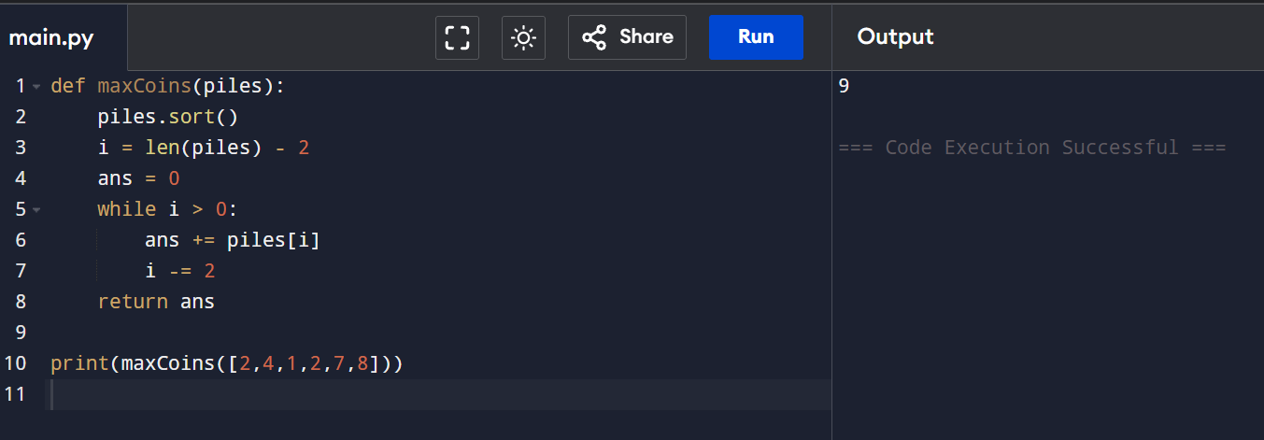
RESULT: Maximum coins obtained successfully.

EXP 2: Minimum Coins to Add

Aim: To find the minimum number of coins needed so all values from 1 to target are obtainable.

CODE
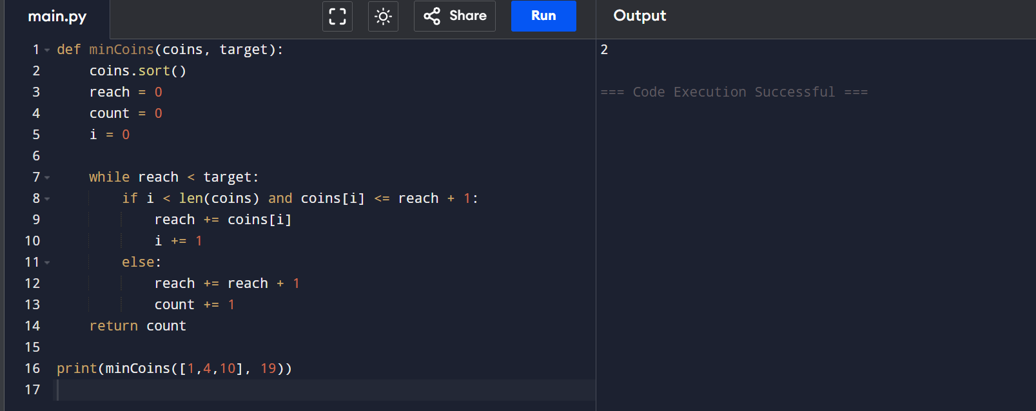

RESULT: Minimum coins added correctly.

EXP 3: Job Assignment (Minimum Max Time)

Aim: To minimize the maximum working time among workers.

CODE

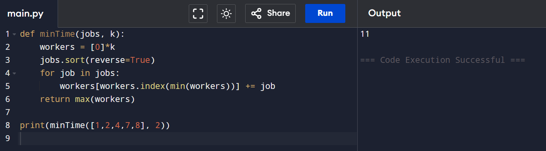

RESULT: Optimal job assignment achieved.

EXP 4: Job Scheduling for Maximum Profit

Aim: To find maximum profit without overlapping jobs.
CODE
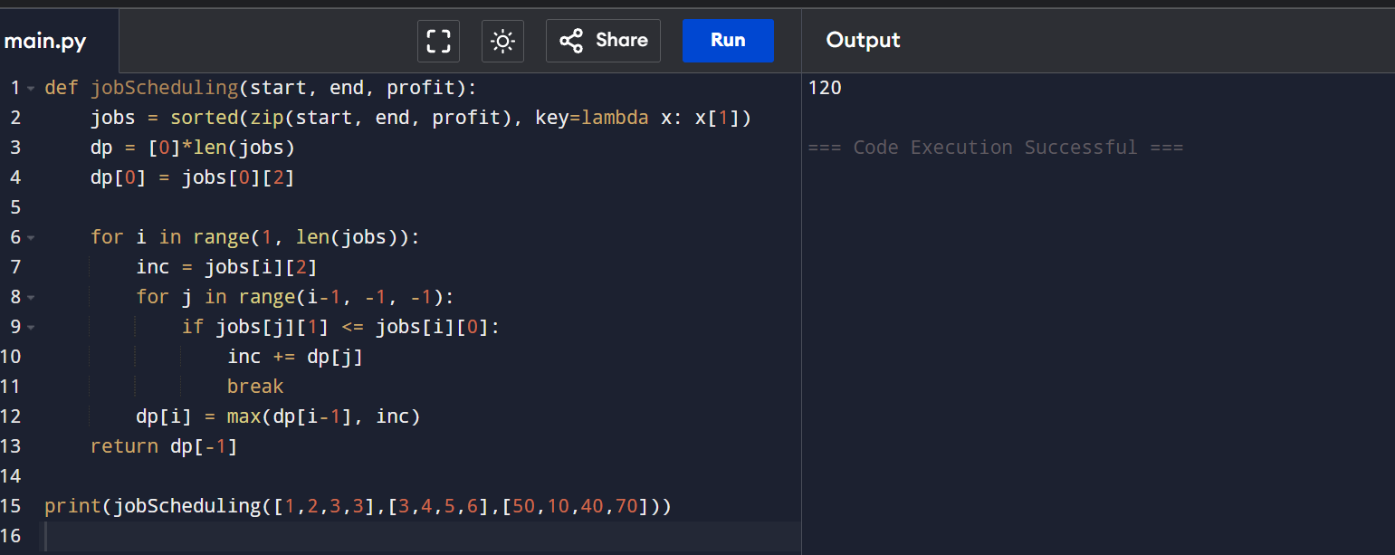
RESULT: Maximum profit calculated successfully.

EXP 5: Dijkstra (Adjacency Matrix)

Aim: To find shortest paths from source to all vertices.
CODE
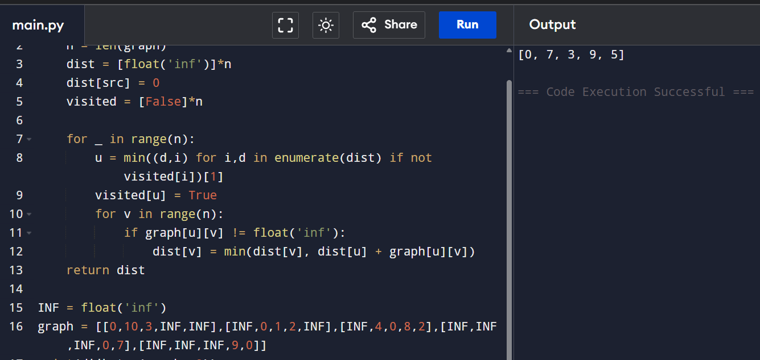
RESULT: Shortest paths found correctly.

EXP 6: Dijkstra (Edge List)

Aim: To find shortest path from source to target.
CODE
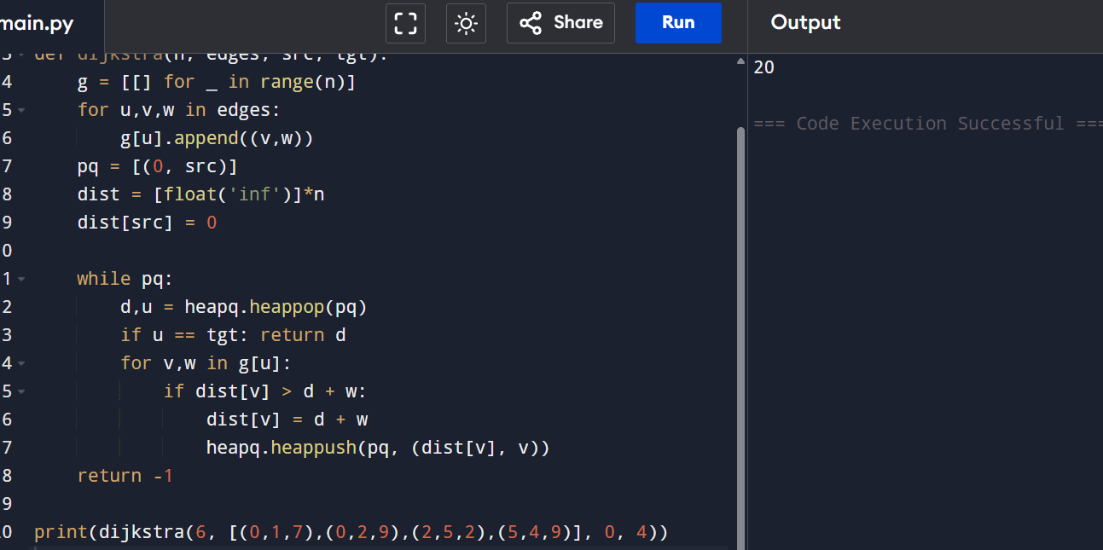
RESULT : Shortest path found.

EXP 7: Huffman Coding

Aim: To generate Huffman codes.
CODE
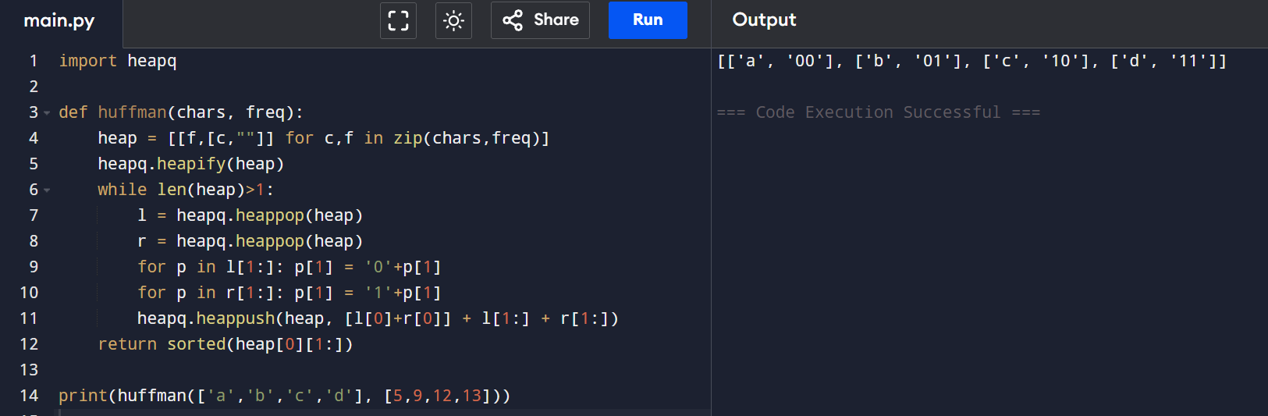
RESULT: Huffman codes generated.

EXP 8: Huffman Decoding

Aim: To decode a Huffman encoded string.
CODE
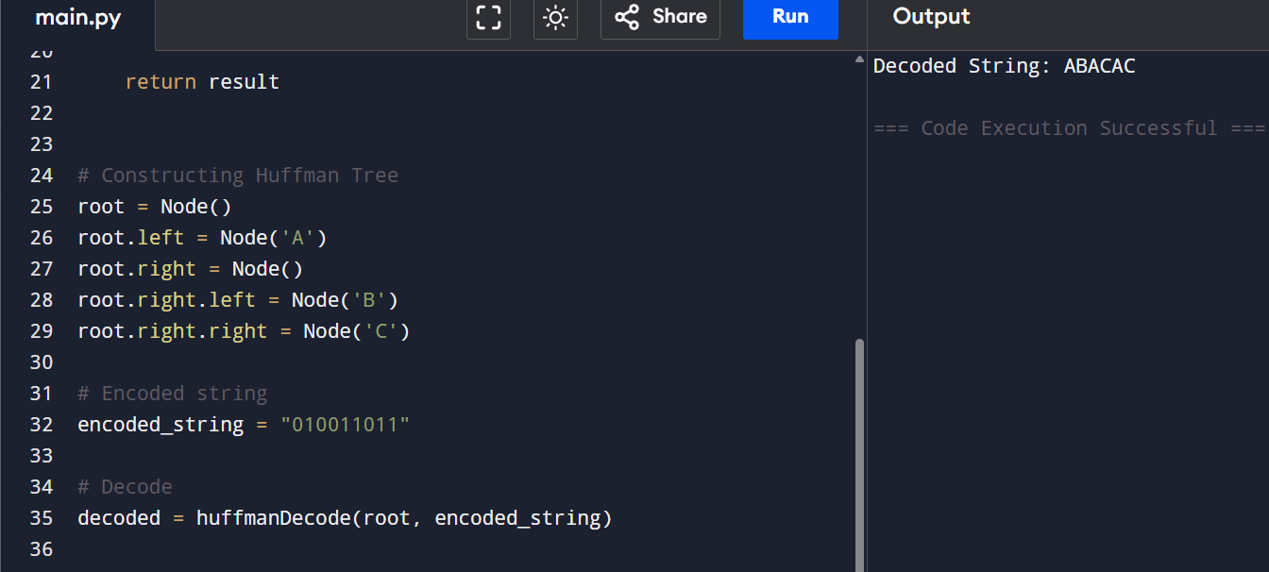
RESULT: Encoded string decoded successfully.

EXP 9: Max Weight (Greedy)

Aim: To load maximum weight without exceeding capacity.
CODE
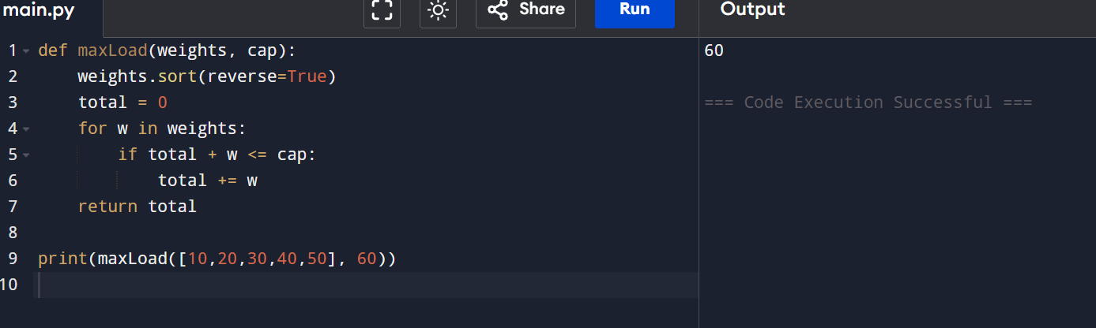
RESULT: Maximum weight loaded.

EXP 10: Minimum Containers

Aim: To find minimum containers required.
CODE
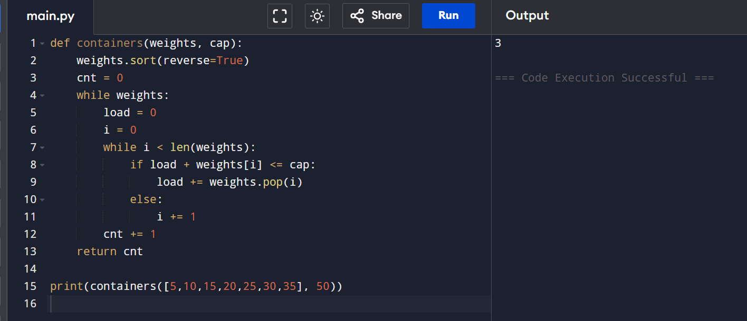
RESULT: Minimum containers calculated.

EXP 11: Kruskal’s Algorithm

Aim: To find MST and its weight.
CODE
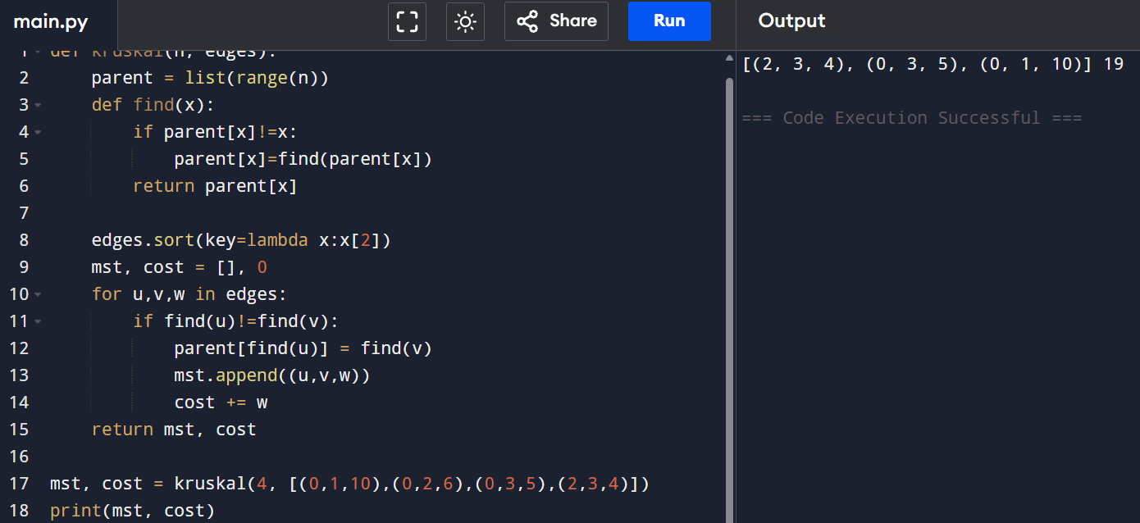
RESULT: MST found successfully.

EXP 12: Check MST Uniqueness

Aim : To check whether MST is unique.
CODE
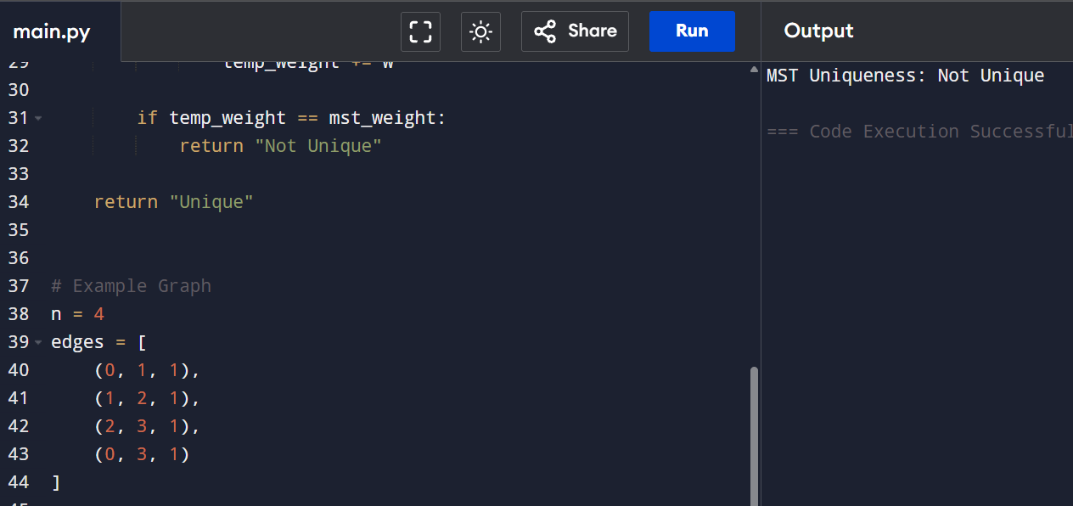
RESULT: If multiple MSTs with same total weight exist → Not Unique

